print one to 10 numbers

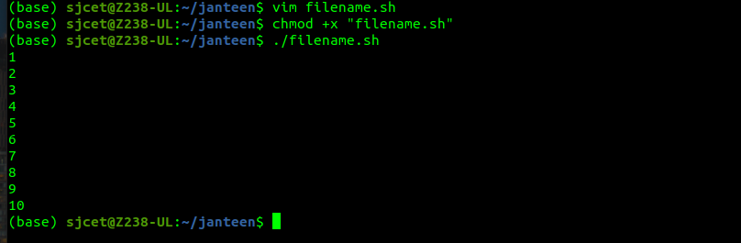
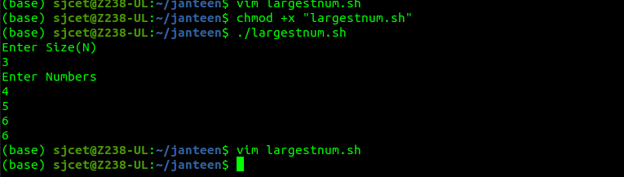

find the largest programs

find average of the num
